Urgent plea for all to help end Manus crisis

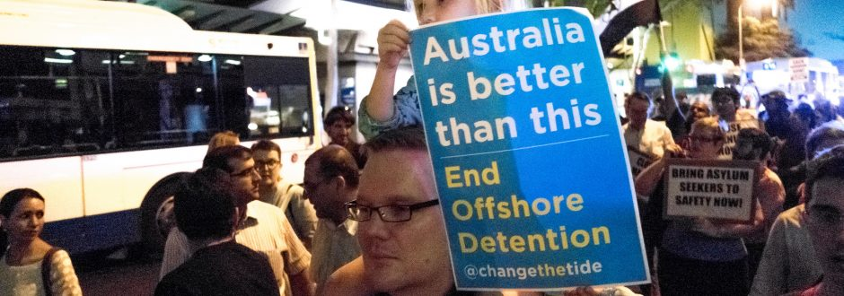
Photo credit: Sheridan Tighe Flickr CC BY-NC-SA 2.0

Sister Patty Fawkner, newly-elected Congregational Leader of the Good Samaritan Sisters, has joined with the voices of many who are urgently calling on the Australian Government and all Federal Parliamentarians to find a humane and just solution to the current humanitarian crisis on Manus Island, Papua New Guinea, where the safety, health and well-being of over 600 refugees and asylum seekers is in jeopardy.

“The disturbing situation on Manus Island has gone on for too long – four years too long, in fact,” said Sister Patty Fawkner.
“Along with many other concerned individuals and groups throughout Australia and internationally, I call on all our Federal Parliamentarians, but particularly those in the Government, to urgently find a humane and just solution to the current humanitarian crisis at the Manus detention centre.
“The men on Manus have languished in detention for too long; they have been held in limbo, not knowing their futures. Many of them have been recognised as refugees, while others are seeking asylum. But even though it’s their legal right to seek asylum, our Government has treated them all – whether refugee or asylum seeker – as detainees, people to be punished.
“Our Government’s punitive approach to asylum seekers and refugees is only adding to the suffering and trauma of very vulnerable people.”
Patty said the Sisters of the Good Samaritan “strongly endorsed” a statement released last week from Bishop Vincent Long, Bishop Delegate for Migrants and Refugees on behalf of Australia’s Catholic Bishops, and a joint Catholic statement from the Catholic Alliance for People Seeking Asylum (of which the Sisters are a member), Catholic Social Services Australia, Jesuit Refugee Services and Jesuit Social Services.
“My Sisters and I urge the Government to accept New Zealand’s offer to resettle 150 refugees, and to bring the remaining refugees and asylum seekers to Australia as soon as possible where they can be resettled or have their claims processed in safety and with dignity,” said Patty.
“The time has come to end Australia’s inhumane and unsustainable policy of offshore processing and detention, whether it’s on Manus Island, Nauru or elsewhere. It has failed.”
At the time of publishing, over 400 men were still refusing to leave the now-closed detention centre on Manus Island, where access to water, food, power and health services was cut off on October 31.
It has been reported that the men are refusing to relocate to alternative accommodation at Lorengau because they fear for their safety.
“I strongly encourage all people of good will to express their concern for the desperate circumstances of the men on Manus Island by contacting our Federal Parliamentarians to demand an immediate change to this cruel, expensive and unworkable policy,” said Patty.
“Our elected political leaders need to hear our concerns. At times like this our collective voices can make a huge difference.”

What you can do
You can help by contacting our elected politicians and expressing your concern.
- Prime Minister Malcolm Turnbull Ph: (02) 9327 3988
- Minister for Immigration and Border Protection Peter Dutton Ph: (07) 3205 9977
- Leader of the Opposition Bill Shorten Ph: (03) 9326 1300
- Shadow Minister for Immigration and Border Protection Shayne Neumann Ph: (07) 3201 5300
- Or your Federal member (contact details here)

